**INTERNSHIP REPORT – TASK 3**

**Title:** Protein Structure Prediction and Visualization

**Name:** [Navya Thalathoti]  
**Internship:** CodeAlpha  
**Course / Department:** [Bioinformatics] B.TECH

**Gmail**:navyathalathoti@gmail.com

**1.Objective**

To predict the three-dimensional (3D) structure of a selected protein from UniProt using SWISS-MODEL or AlphaFold DB, visualize it in PyMOL, and analyze its structural features.

**2. Protein Details**

| **Feature** | **Details** |
| --- | --- |
| Protein Name | Insulin |
| UniProt ID | P02144 |
| Organism | *Homo sapiens* |
|  |  |

**3. Methods**

**3.1 Sequence Retrieval**

* Retrieved protein sequence in FASTA format from **UniProt**.
* Saved as insulin.fasta.
* Sequence:

>sp|P01308|INS_HUMAN Insulin OS=Homo sapiens OX=9606 GN=INS PE=1 SV=1

MALWMRLLPLLALLALWGPDPAAAFVNQHLCGSHLVEALYLVCGERGFFYTPKTRREAED

LQVGQVELGGGPGAGSLQPLALEGSLQKRGIVEQCCTSICSLYQLENYCN

* 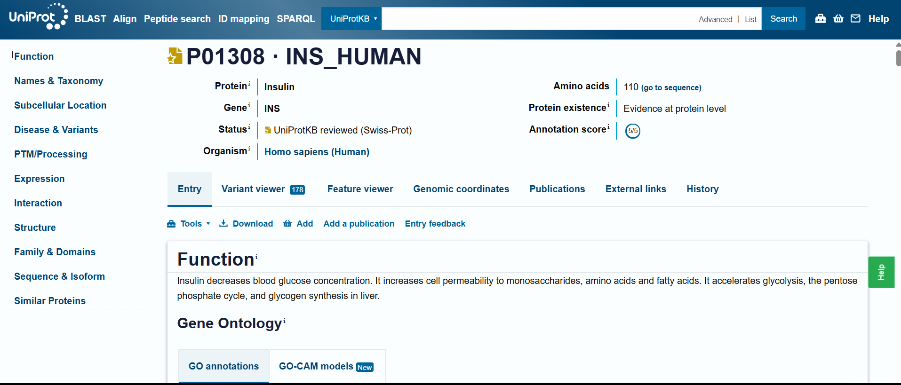

**3.2 Structure Prediction**

* Predicted 3D structure using **SWISS-MODEL** / **AlphaFold DB**.
* Downloaded the predicted **PDB file**.
* 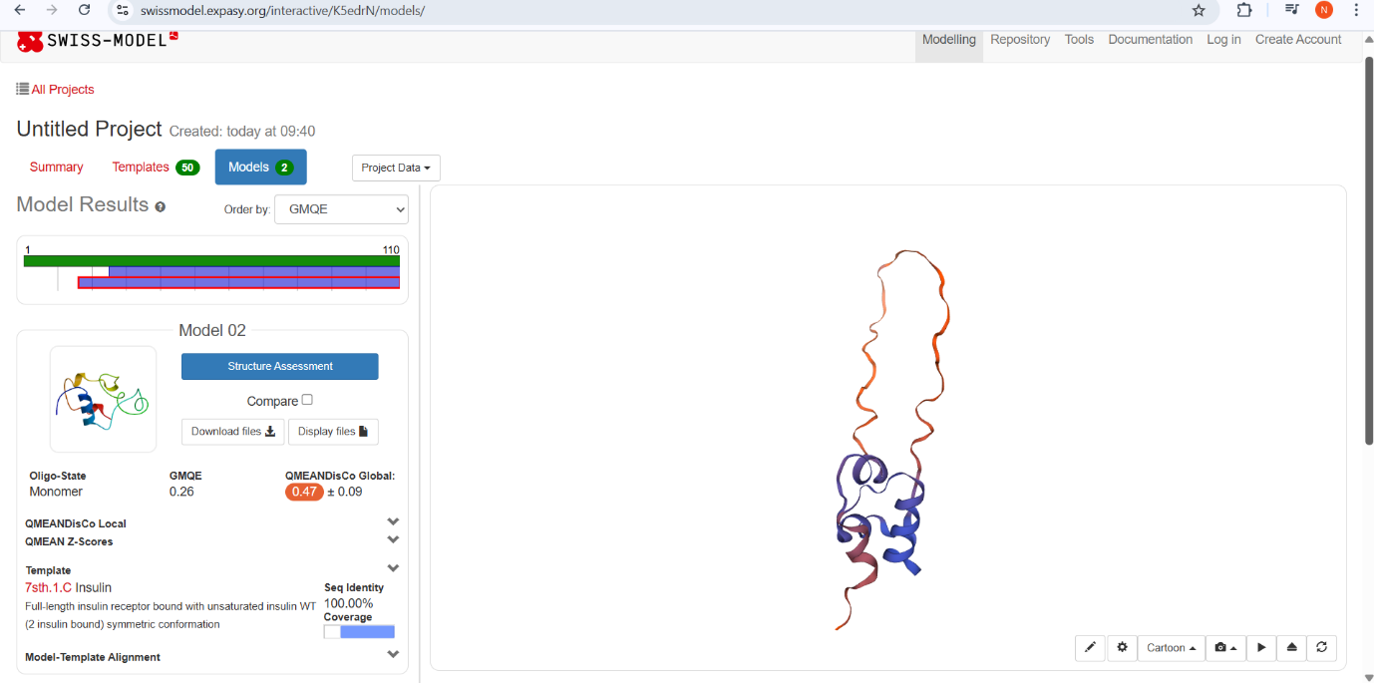

**3.3 Visualization in PyMOL**

* Opened PDB file in PyMOL.
* Commands used:

show cartoon

color cyan, all

zoom all

turn x, 90

png insulin_structure.png, dpi=300

* Visualized the protein from different angles, including surface and cartoon views.
* 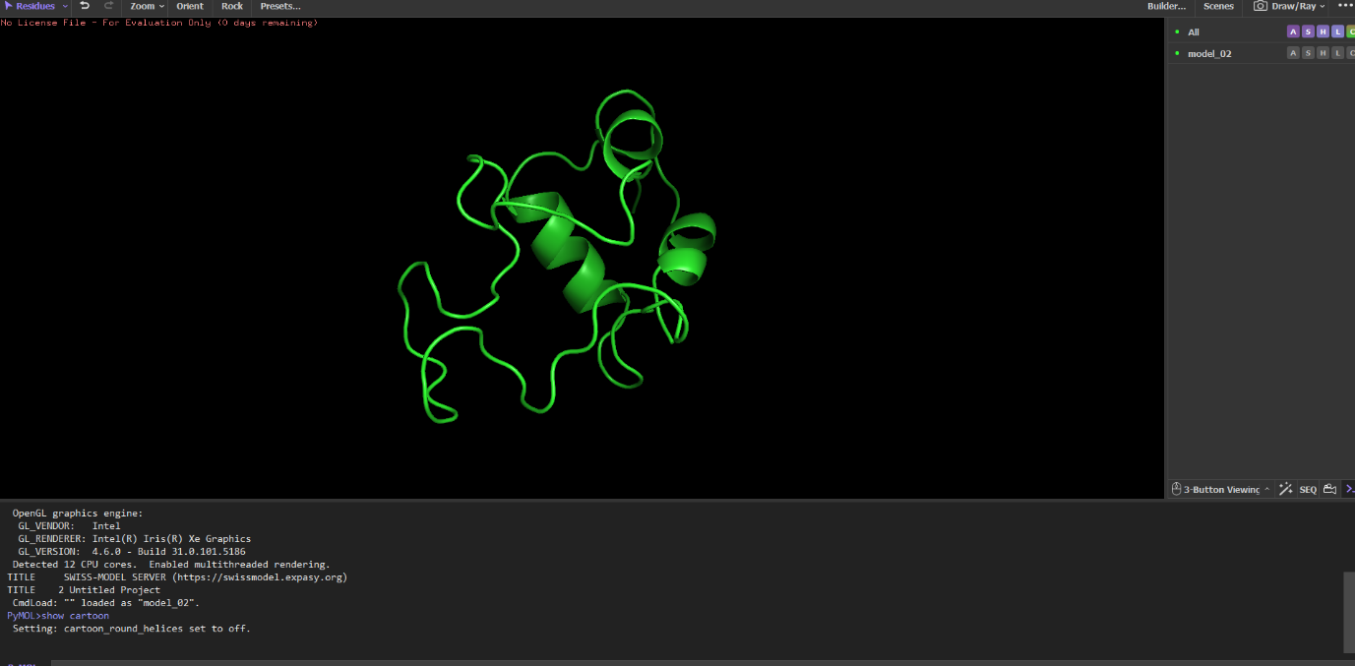
* 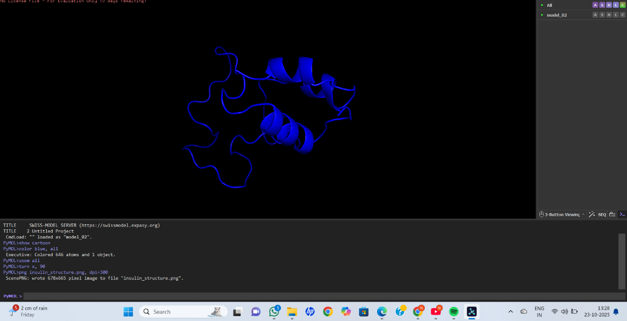
* 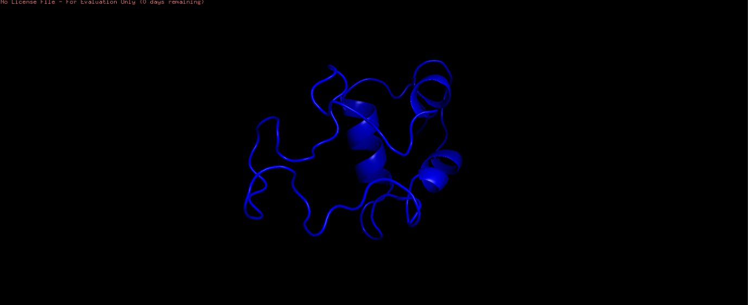

**4. Results / Observations**

* Structure shows **α-helices and loops**, typical for insulin.
* Surface view highlights regions accessible to solvent.
* Predicted model confirms the **compact folding** necessary for biological function.

**5. Structural Features**

| **Feature** | **Observation** |
| --- | --- |
| Secondary structure | α-helices and loops |
| Active site / functional region | Residues forming disulfide bonds (Cys7–Cys19, Cys20–Cys31) |
| Shape | Globular compact |
| Stability | Structure confirmed by PyMOL visualization |

**6. Conclusion**

The 3D structure of insulin was successfully predicted and visualized.  
The PyMOL images clearly show secondary structure elements, active regions, and overall fold, which helps in understanding protein function.